Programming instructions for the XDS100 Emulator
1) Download and install the FTDI D2XX Drivers found here. (scroll down, the link for the driver is in the center column of the table on the page)
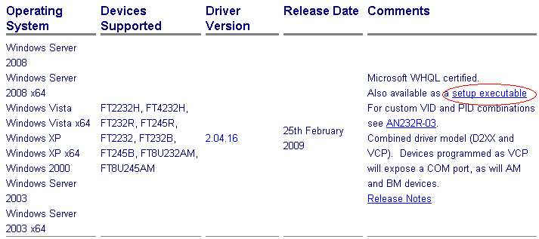
2) Download and install the MProg program found here.
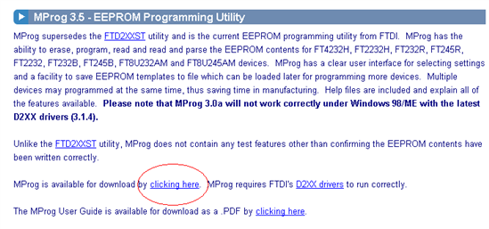
3) Locate XDS100_wUART.ept file included with this document. It can also be downloaded here.
4) Connect the board using a USB B-A cable to a host computer.
5) Open MProg. Under the File menu select Open and then select the XDS100_wUART.ept file.
6) Under the Device menu select Scan. MProg should give the result below, showing that there is one blank device.
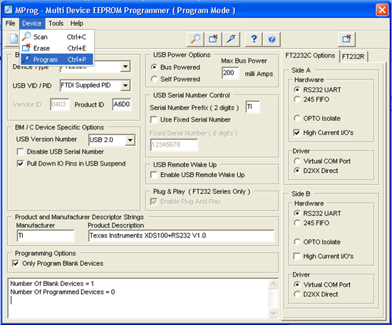
7) As the above picture shows, select Program under the Device menu. MProg will program the EEPROM on the board and should give a result similar to the one below.
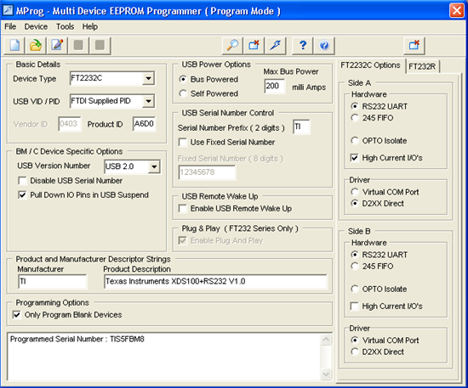
8) On a SEPARATE computer that has not had any of the FTDI software installed, install Code Composer Studio V3.3

9) Connect the board to the USB port of that computer.

10) Windows might, or might not install drivers. Open device manager(right click My Computer -> Properties -> Hardware -> Device Manager) and look for the items circled in the picture below. The “COM16” might be different something different but “USB Serial Port” should appear. If both USB Serial Port and TI XDS100 Channel A and B appear then the XDS100 has been programmed properly.
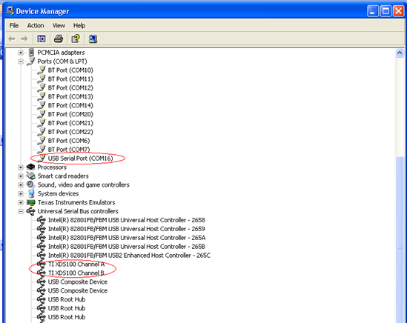

11) Follow any other board specific verification and test procedures.

